CYBERSECURITY LAB SETUP REPORT
LAB ARCHITECTURE OVERVIEW:
- SIEM AND TELEMETRY CORE:
- CENTRAL SIEM MANAGER: Wazuh security server deployed as the as the centralized detection machine.
- ENDPOINT TELEMETRY:wazuh agent installed and running kali linux.
- LOG INGESTION:continuous system,module and log collector monitoring active.
- NETWORK AND TARGET SEGMENT:
- ISOLATED NETWORK: configured using virtualBox Host-only Ethernet Adapter(192.268.56.0/24)
- ATTACK VM: kali linux configured as auditor and security monitoring host
- TARGET VM: metaspliotable Ubuntu target hosted on the same subnet.

SUBNET AND HOST MAPPING

Host/system name | Role | Ip address | MAC/Adapter | Operational status
Wazuh security server | SIEM/log collector engine | 192.168.56.101 | 08:00:27:62:ee:f0 | Active and running
Kali linux | Attacker and managed endpoint | Dynamic /subnet IP | Host-only interface | Active/agent up
Metaspliotable vm | Vulnerable machine | 192.168.56.102 | 08:00:27:a3:02:54 | Active /online
Virtualbox network | Isolated host-only subnet | 192.168.56.0/24 | Host Ethernet adapter | connected

WAZUH SIEM SERVER INITIALIZATION
- Open source security platform:deployed as the primary central threat monitoring server.
- Newtwork binding: interface eth0 configured on subnet 192.168.56.0/24
- Service readiness: active console ready to receive agent registration and securitylog streams.
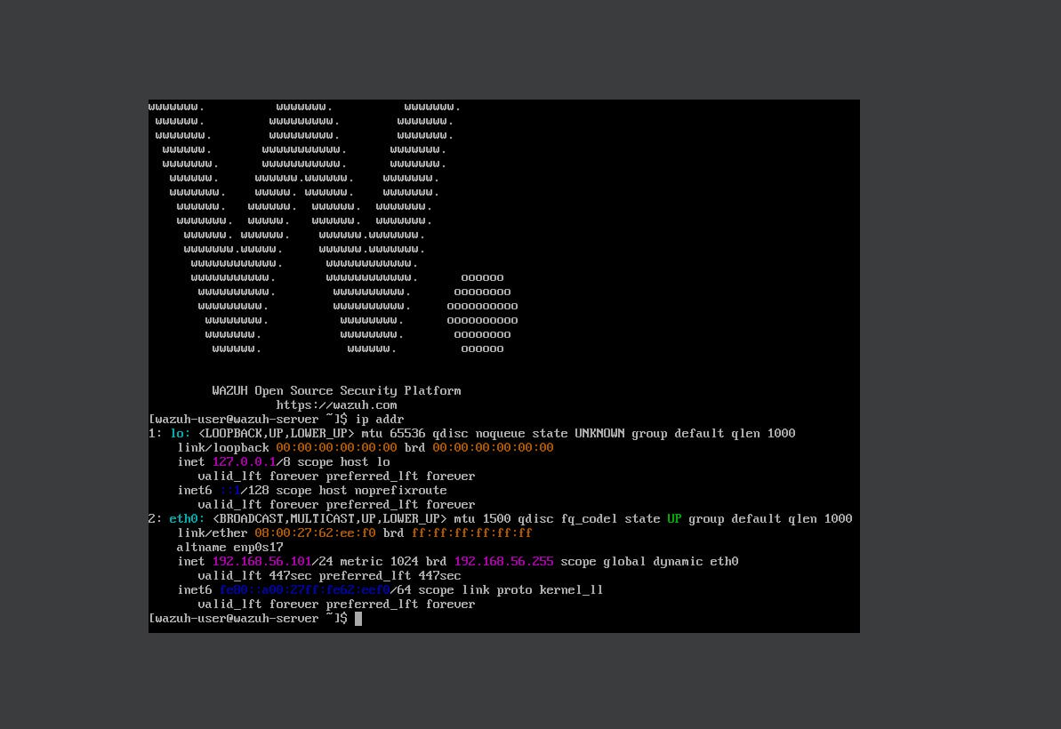
WAZUH DASHBOARD ACTIVE AND RUNNING
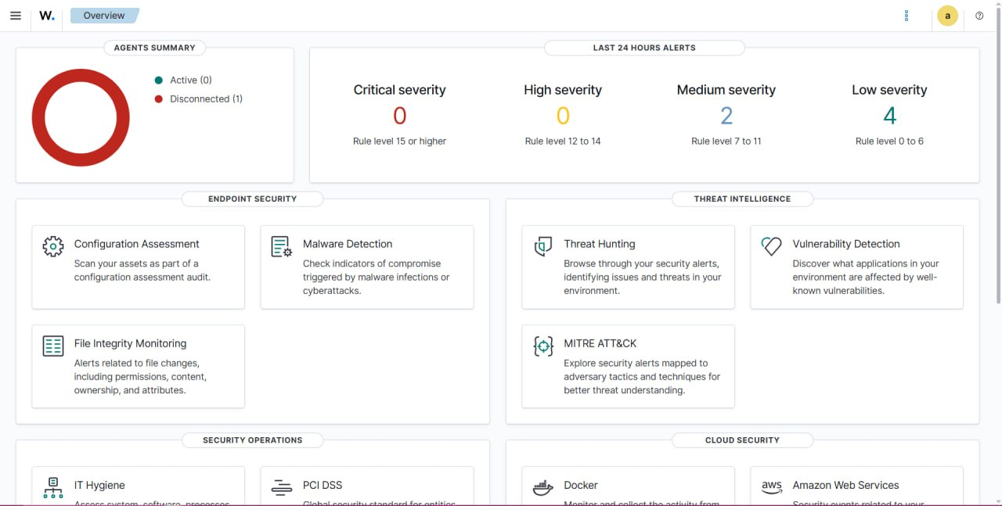

ENDPOINT AGENT SERVICE VERIFICATION
- AGENT DEPLOYMENT: installed and enabled wazuh-agent service on kali linux.
- ACTIVE STATE: verified active status ( status=0/success) via systemctl.
- CORE DAEMO S ACTIVE: process initialized include execd,syschecked,logcollector, and modulesd.
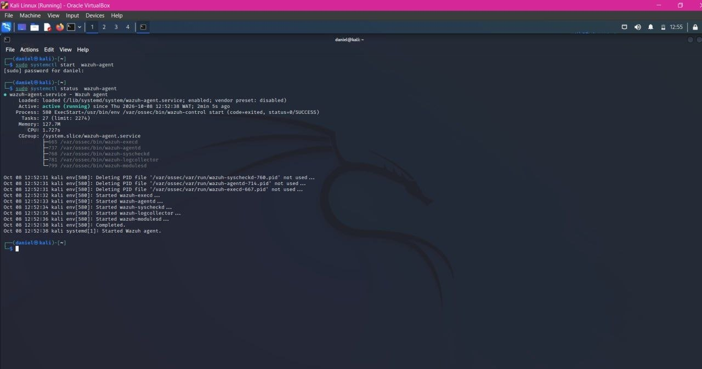

KALI TO SIEM CONNECTIVITY TEST
- ICMP ECHO VERIFICATION:executed ping test from kali linux to wazuh siem server .
- ZERO PACKETS LOSS: 6 packets transmitted and 6 packests received cleanly(0% loss).
- ULTRA-LOW LATENCY:average round –trip time recorded at 0.617 ms.
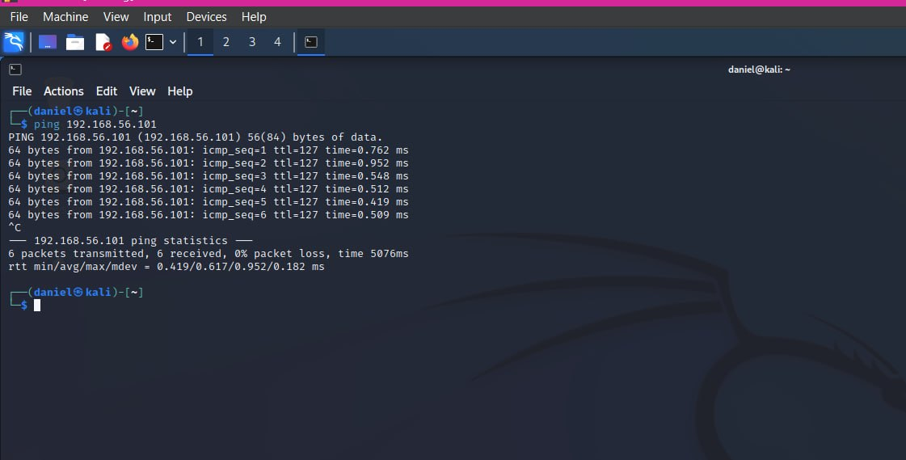
TARGET VM NETWORK SETTINGS
- HYPERVISOR CONFIGURATION: VirtualBox manager setting for metaspliotable.
- ADAPTER MODE: network adapter 1 bound to host-only adapter.
- HARDWARE LINK: virtual cable connected enabled;assigned MAC address 080027A30254.
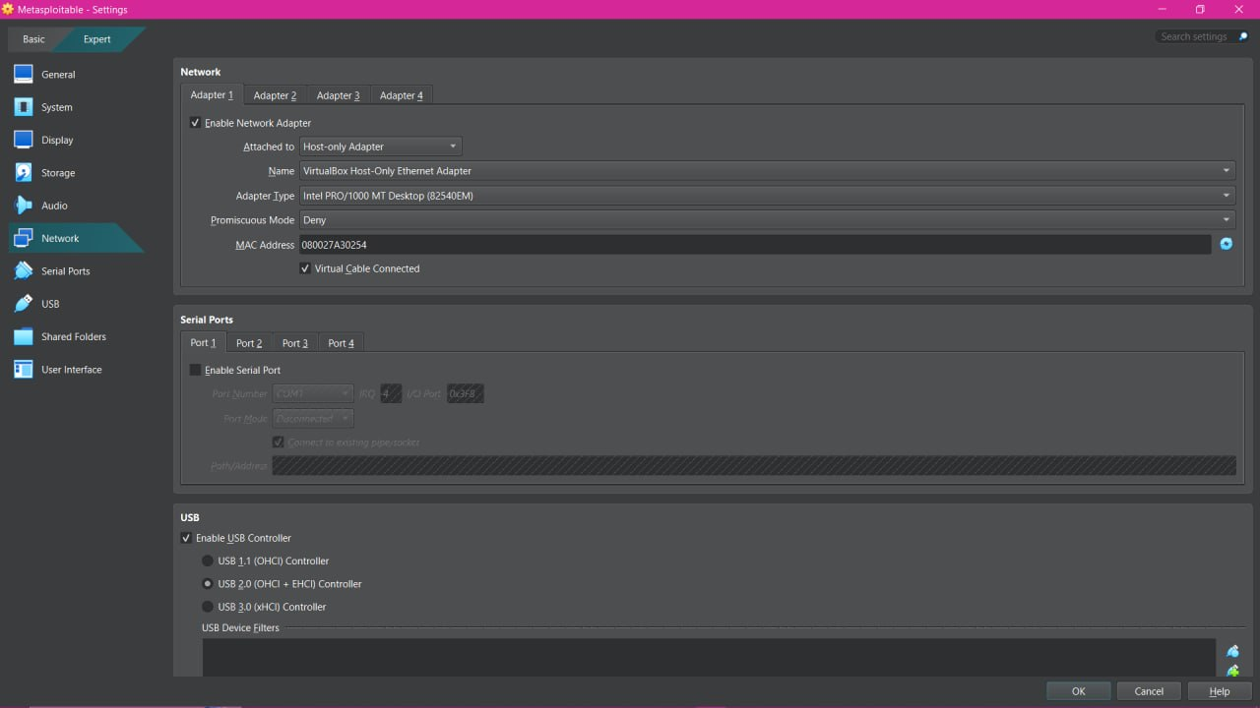
TARGET NODE ADRESS INTERROGATION
- GUEST OS BOOT: Metaspliotable target system started and accessible.
- IP ASSIGNMENT: executed ip 192.168.56.102/24 on eth0.
- MAC VERIFICATION: interface confirmed matching hardware settings (08:00:27:a3:02:54).
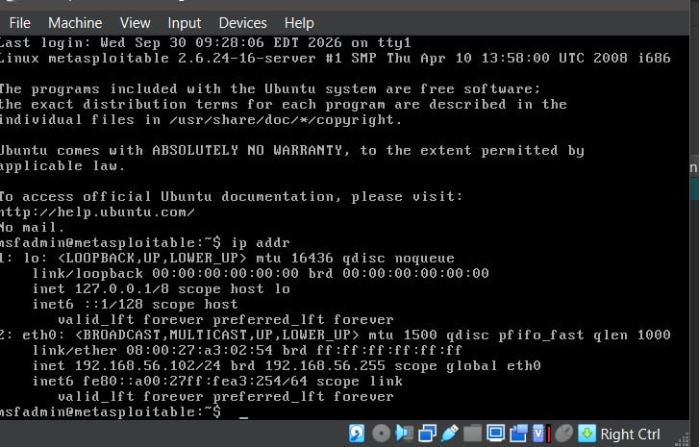
KALI TO TARGET REACHABILITY TEST
- END-TO-END ROUTING : ping test initiated from kali linux to target node 192.168.56.102.
- FULL PACKET DELIVERY: 16 packets transmitted with 16 replies received (0% packet loss).
- READY FOR AUDIT: target is fully reachable for network scans, vulnerability assessment , and exploitation labs.
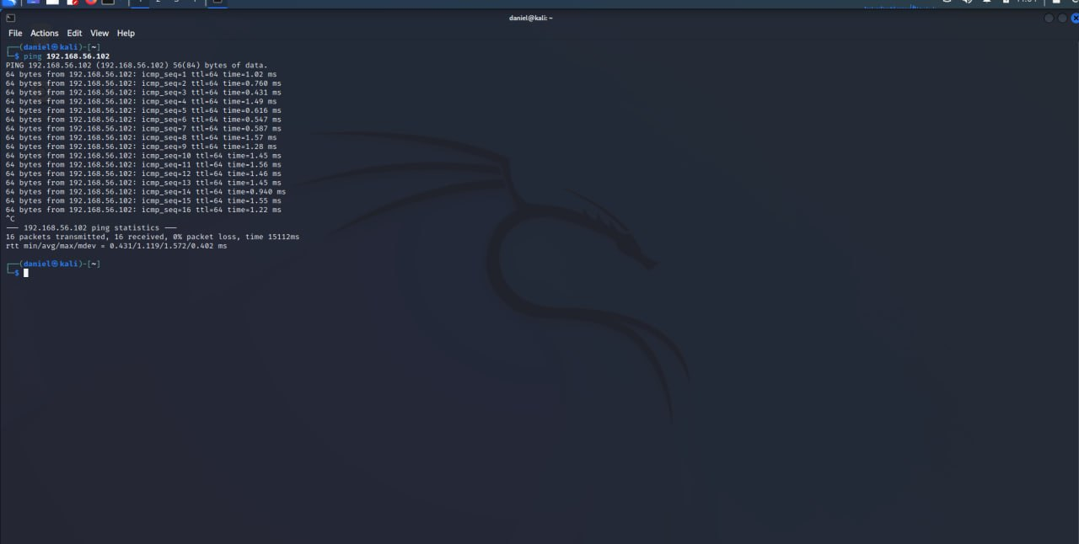

LAB VERIFICATION SUMMARY
- 3 virtual machines active:kali linux ,wazuh SIEM, and metaspliotable successful provionsed.
- 0% packets loss:confirmed across all inter-VM communication tests on the host-only adapter.
- Wazuh agent running: active telemetry collected established on auditor host.

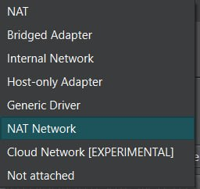

- NAT: Gives a VM internet access through the host.
- Bridged Adapter: Connects a VM directly to your physical network.
- Internal Network: Allows VMs on the same internal network to communicate privately.
- Host-only Adapter: Allows VMs and the host computer to communicate privately.
- Generic Driver: Supports specialized networking configurations.
- NAT Network: Allows VMs to communicate with each other and access the internet.
- Cloud Network: Connects VMs to supported cloud networking environments.
- Not Attached: Disconnects the VM from the network.

Best for the Home Lab we create: Host-only adapter

